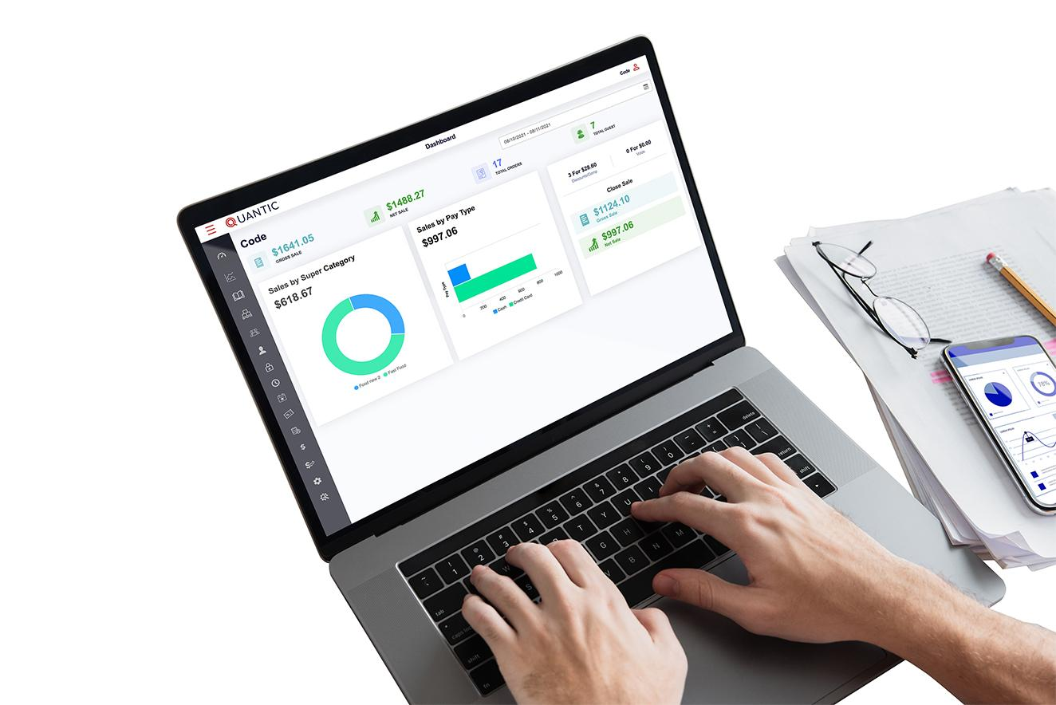

Enterprise User Manual

## A Simple Step-By-Step Guide

## Table of Content

A Simple Step-By-Step Guide 1

Table of Content 2

Introduction to the Enterprise 3

Key Features 3

Limitations on sharing the Data from Parent to Child 4

FAQs 7

How to Create a Parent Enterprise Location? 7

How to Create a Child Location? 8

How to Setup a Child Location? 10

How to Push Items from Parent to Child? 13

How to Add Stock in Child from Parent? 16

## 

## Introduction to the Enterprise

The enterprise module is the most beneficial feature for Quantic customers having multiple locations. All or some of the child locations can be linked with the parent location. Once the locations are linked, you can push the menus from the parent to all the linked child locations in just a single click. For example, your restaurant can share menus like super-categories, categories, items, modifiers, and so on. Below are the exclusive benefits of using the Quantic Enterprise module.

## Key Features

1. **Total Control on the Child Location Menus**
   1. Quick menu publishing all across your child locations. Build one at the Parent location and share it with all your child locations.
   2. Choose what menus to push and what not, to the child locations.
   3. Delink the menus whenever you want.
   4. Set location-specific pricing for the menu items.
2. **Manage Inventories**
   1. Allocate the stocks for menu items from the parent location.
   2. Track the remaining stock of all the child locations from a single dashboard.
   3. Add more stocks of items, if needed, to the child locations.
3. **Dedicated Change Management Dashboard**
   1. Keep track of all pending and complete changes.
   2. Change the item name, price, item description, and category and push in a single shot.

## Limitations on sharing the Data from Parent to Child

There are some properties that you can share from Parent to Child while there are a few that you cannot. Please check the properties below.

| **Item Property** | **Shared between parent and child** | **Not shared, child-specific instead** |
| --- | --- | --- |
| Item Name - POS/Kitchen/Receipt/Web | ✔️ |  |
| Modifier and Submodifier | ✔️  Shared along with the associated item |  |
| Supercategory/Category/Subcategory | ✔️  Shared along with the associated item |  |
| Item Price - Store or Web | ✔️ |  |
| COG | ✔️ |  |
| Tax Class or Additional Tax Class |  | ✔️  If the Parent location’s default tax is attached to the item, the item will push to apply the default tax of the child location. |
| Item Image | ✔️ |  |
| Item Description | ✔️ |  |
| Disable or Delete Item |  | Child cannot delete the item that the Parent has shared |
| Printer |  | ✔️ |
| KDS |  | ✔️ |
| Terminal |  | ✔️ |
| Meal Period |  | ✔️ |
| Item Background Color in POS | ✔️ |  |
| Combo Item |  | ✔️ |
| Enable for Web | ✔️ |  |
| Web Description | ✔️ |  |
| Category Inheritance | ✔️ | Child cannot edit the inherited properties that the parent has shared |
| All Item Level Settings | ✔️ | Event, Course list, Price list are not shared |
| Legal consumption age | ✔️ |  |
| Item unit | ✔️ |  |
| Item Inventory |  | ✔️ |
| Allocate Inventory (Parent To Child) | ✔️ |  |
| SKU/MPN/UPC/ALU | ✔️ |  |
| Reorder Point |  | ✔️ |
| Associate Vendor | ✔️ |  |
| Track Inventory | ✔️ |  |
| Coursing/Auto-coursing |  | The setting is shared between parent and child, but Child has to create its Course list. |
| Positioning | ✔️ |  |
| Set Tax Inclusive | ✔️ |  |
| Discount and Gratuity eligibility | ✔️ |  |
| Smart-tax enabled item | ✔️ |  |
| Tax Exemption | ✔️ |  |
| Manager only access to item | ✔️ |  |
| Assign promotion to items |  | Child has to create its own item, mod and event list. |
| Item count | ✔️ |  |
| Tare weight | ✔️ |  |
| Price List |  | ✔️ |
| Label print button on the item | ✔️ |  |
| Quick Item or Open Item | ✔️ |  |
| House Account Item | ✔️ |  |
| House Account Payment |  | ✔️ |
| Weighted Item and Qty with Weight and Weight based UPC | ✔️ |  |
| Deposit Item | ✔️ |  |
| Pizza Item | ✔️ |  |
| Gift Card Item | ✔️  But GC module has to be subscribed at Child |  |
| Time Item | ✔️ |  |

## FAQs

### How to Create a Parent Enterprise Location?

### 

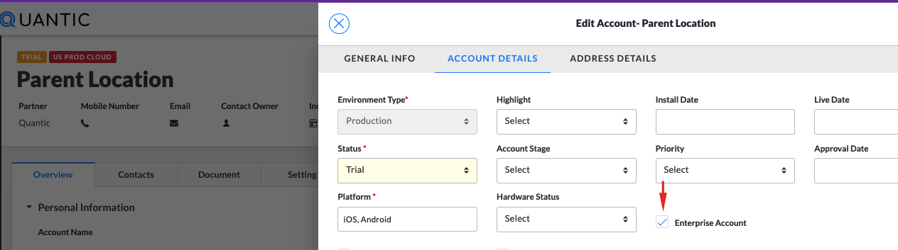

1. While creating a location, Select **Enterprise Account** as shown in the image above. Selecting this option will assign this location as a parent.
2. Finish the location setup and setup the payment gateway like you do for a general locations.

### How to Create a Child Location?

You can create the child location from the Parent itself. Please follow the below steps.

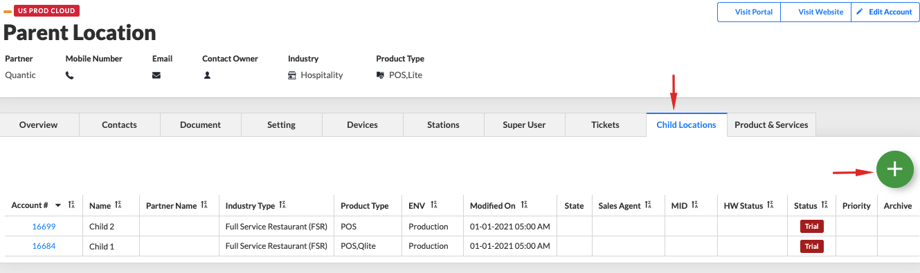

1. Once you are done with the location setup, go to the **Child Locations** tab in Parent Enterprise location.
2. Select the  button to create a child location.

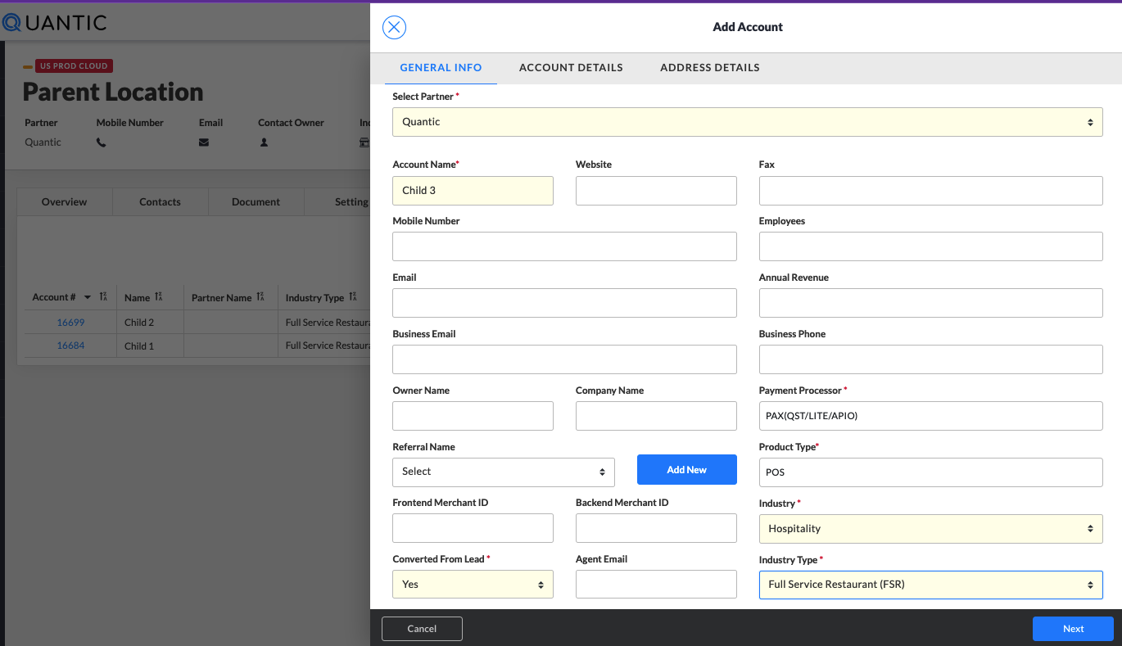

1. Add the account details like account name, payment processors, product type, location address etc., and **Save**.

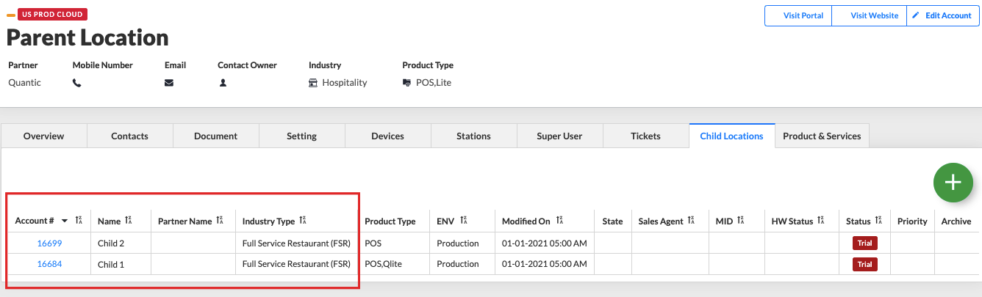

1. Once the Child location is created, it will appear in the **Child Locations** list as shown in the image above.

### How to Setup a Child Location?

### 

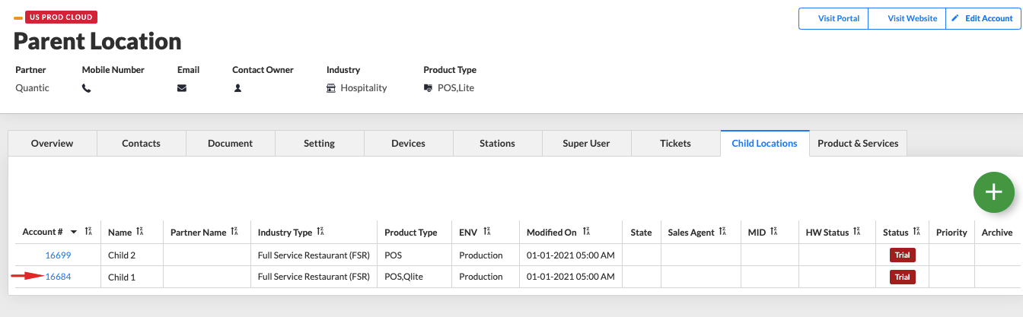

1. Go to the **Child Locations** section in the Parent Enterprise location.
2. Tap on the Child location’s **Account #** that you want to setup.

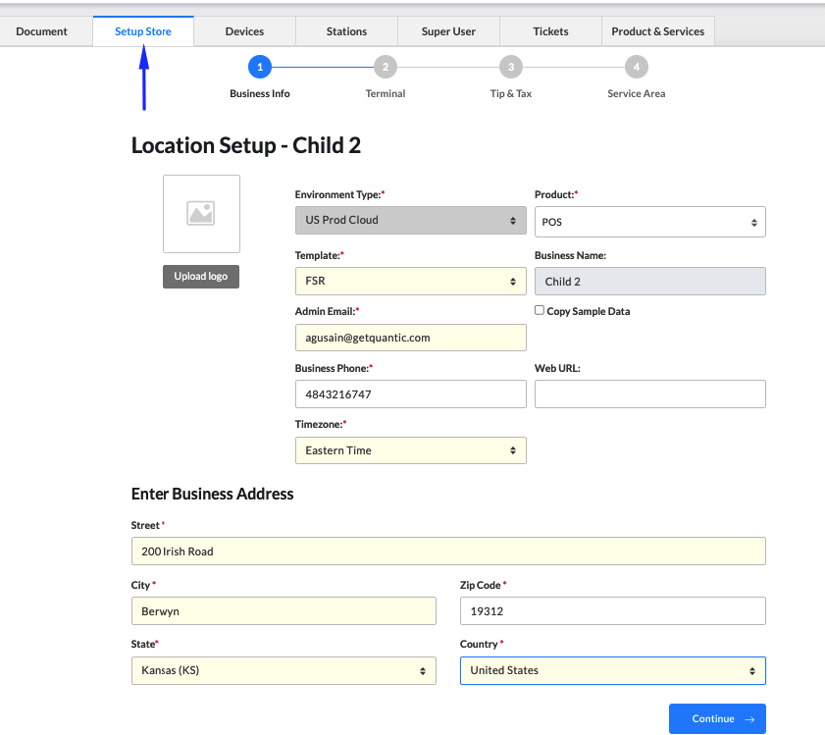

1. Go to the **Setup Store** and add the details as shown above.

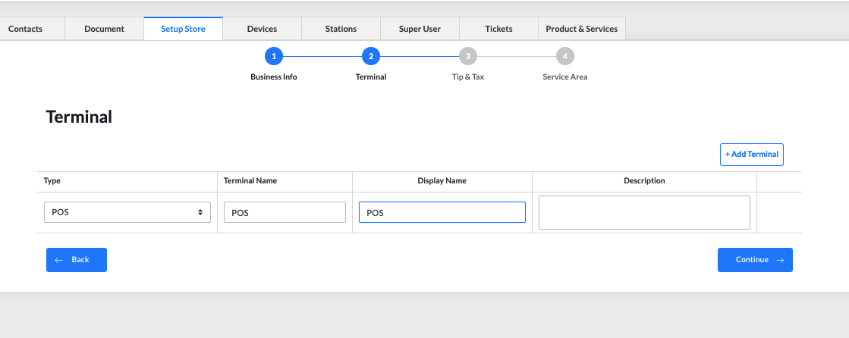

1. Add the **Terminal** details.

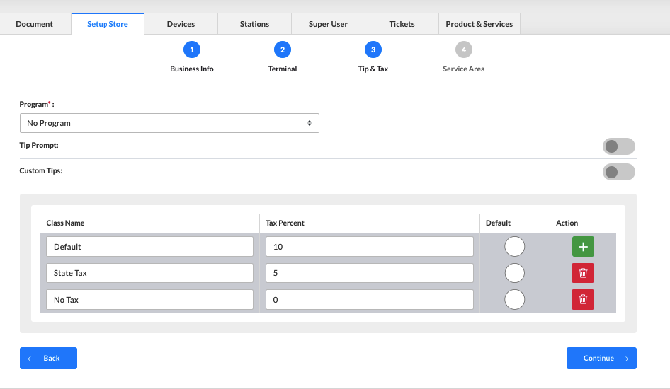

1. Setup the **Taxes** and click **Continue**.

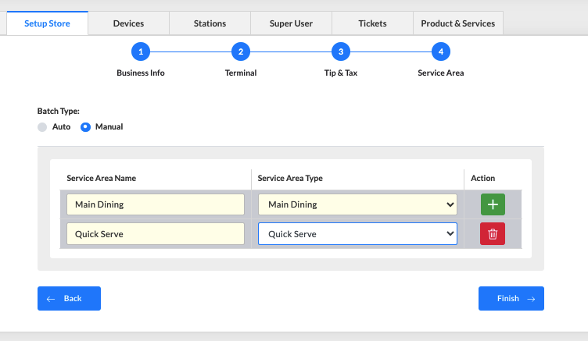

1. Add the service area and click **Finish**.

### How to Push Items from Parent to Child?

### 

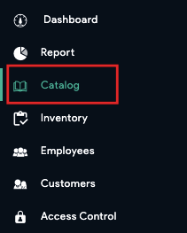

1. Open the Parent location’s backend portal, and click **Catalog** on the left navigation panel.

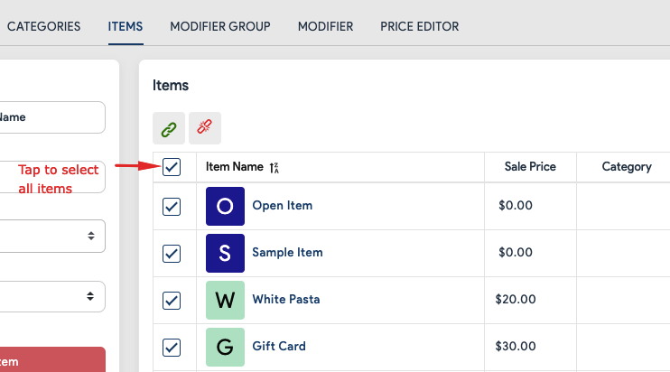

1. Locate the item that needs to be pushed to the child location.

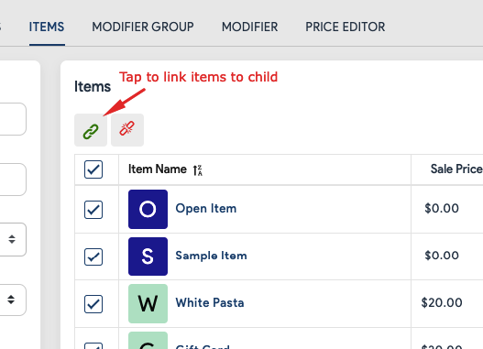

1. Click  next to the item under **Action** to push that item to the child locations.
2. Similarly, you can click the  icon to delink the items.

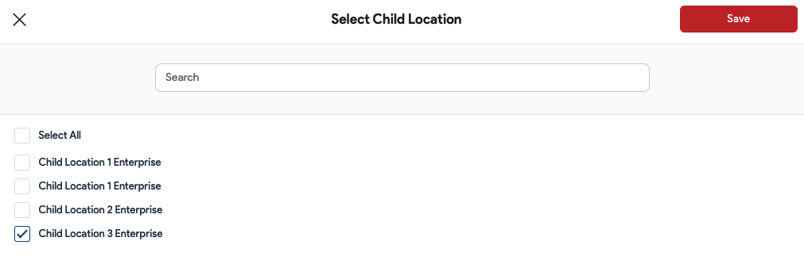

1. Select the child locations from the list and click **Save**.

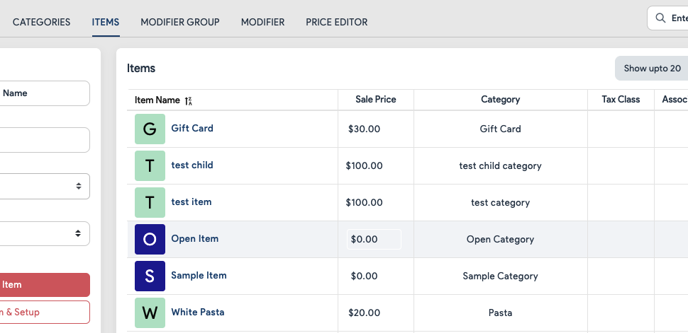

1. Login to the child location to see the item.

### How to Add Stock in Child from Parent?

### 

**Note**: Parent location can only allocate the stocks in the child location. Transferring the stocks from parent to child is not possible.

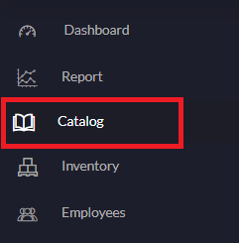

1. Open the parent location’s backend portal, and click **Catalog** on the left navigation panel.

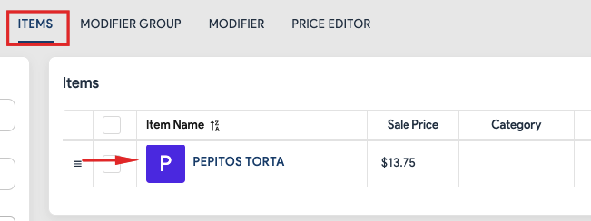

1. Locate the item for which you want to allocate the inventories. Make sure the item is linked with the child location. To verify you can click the  button under **Action** and see the child location has been selected to which you are allocating the stocks.

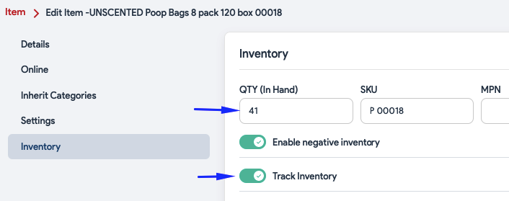

1. Go to the **Inventory** tab and select the **Track Inventory** option..
2. Click **Save** to save the changes.

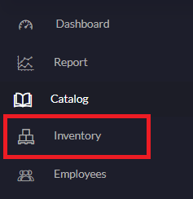

1. Open the **Inventory** on the left navigation.

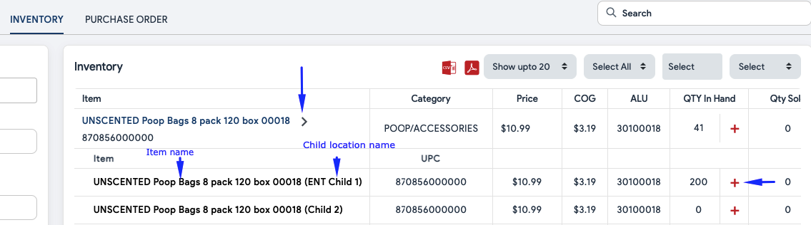

1. Search for the item and tap the  button to expand the child location list where the item has been pushed.
2. The child locations will be displayed underneath to which this item has been pushed.
3. Now tap the  icon next to that item under the **QTY In Hand** section.

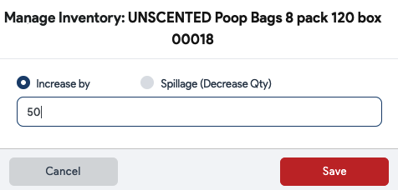

1. Enter the quantity with which you want to increase or decrease the item quantity.
2. Don't forget to click the **Save** button.

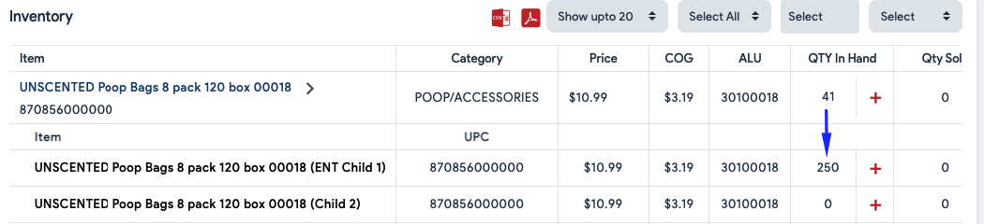

1. Once done, the item quantity will start displaying next to the item name and the same quantity will get updated at the child location’s backend portal.
2. Similarly, you can manage the inventories of all child locations from the parent location.